Jade Pearl
COSC 320-001 Lab 06: Set and Map 3/20/2023

Lab report: I completed this lab in approximately 3 hours. Referred to geeksforgeeks on the implementation/functions in the set and map libraries in order to write the main cpp files in the lab since I decided not to use d_set.h or d_map.h. I also had to search how to implement the iterator and use it for the searching in the set and map

Pre-lab:
- Review the in-class material we have discussed about Set and Map

Files Created:
lab06_set.cpp, lab06_map.cpp, edited the given file d_state.h

Lab 6
Exercise 1: Read and understand the header files d_set.h and d_map.h
Exercise 2: read and understand d_state.h. Finish it’s implementation:
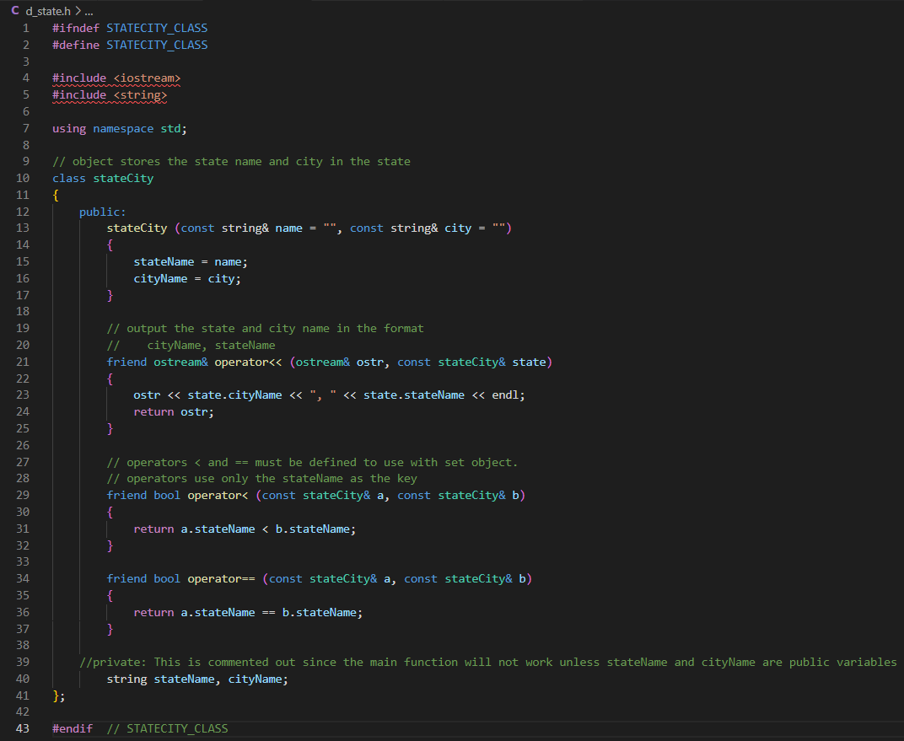

Lab06_set.cpp source code:
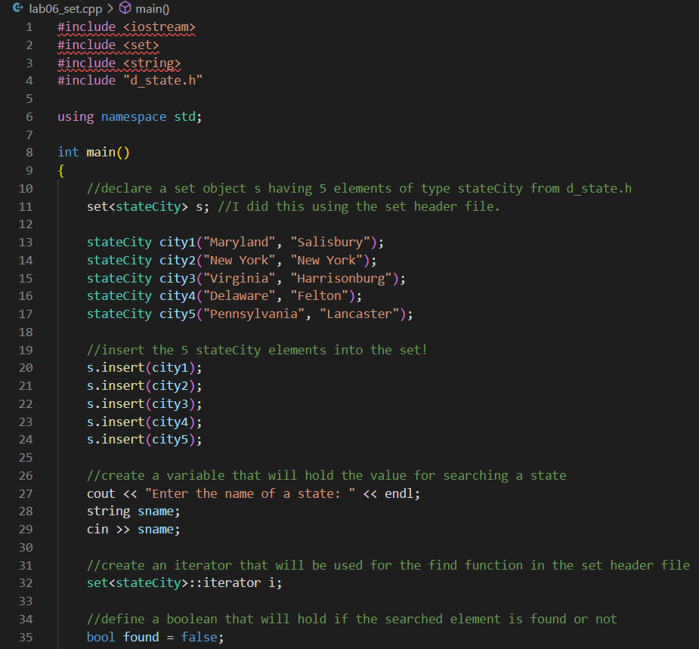
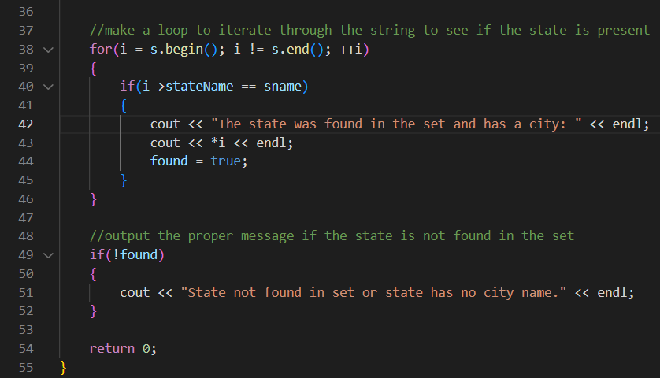

Lab06_set.cpp sample outputs:
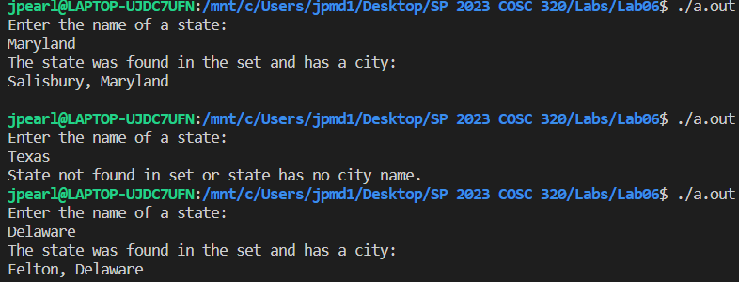

Lab06_map.cpp sample code:
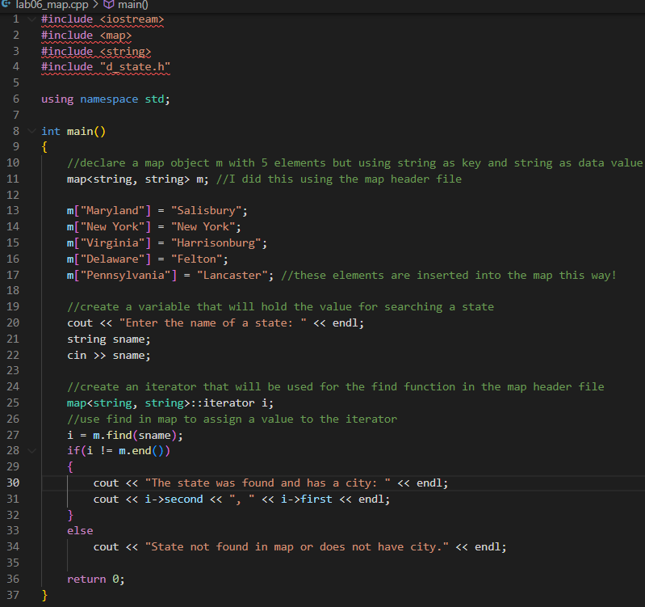

Lab06_map.cpp sample outputs:
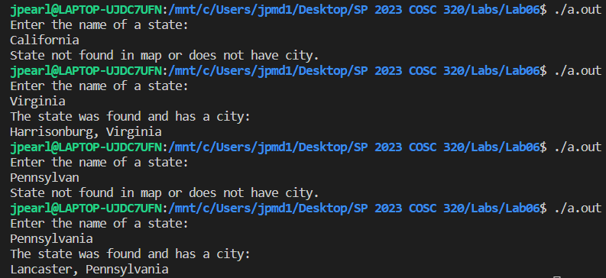

Notice that for the Lab06_map.cpp, I did four different outputs instead of the usual three. I was showing with the Pennsylvania search that the search is indeed case sensitive because Pennsylvan made the program show that there was not a state by that name in the map but Pennsylvania did so the user has to keep in mind that the search is case sensitive and that they have to use correct spelling for states and no abbreviations in this case.

